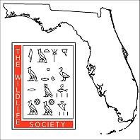
FLTWS Graduate Student Scholarship Recommendation Form

The Scholarship Committee of the Florida Chapter of The Wildlife Society (FLTWS) would appreciate a candid evaluation of the candidate who has applied for a FLTWS Graduate Student Scholarship, from a chair or member of the graduate student’s committee. Please answer a few questions about yourself and your relationship with the student. Please then rank the applicant in each of the categories listed. Additional description regarding the qualifications of the student would be very much appreciated at the bottom of the page. Thank you.

Student Applicant Name:
Recommender Name:
Recommender Title/Affiliation:
How long have you known the applicant?
In what capacity have you known the applicant?

Please rank the applicant in the categories below, relative to other graduate students you have interacted with:
 | Top  5% | Top  10% | Top  25% | Top  50% | Lower 50% | Unable to rate
Knowledge in area of study
Ability to conduct field or lab research
Originality; intellectual creativity
Motivation; drive; initiative
Ability to express self orally
Ability to express self in writing
Supervisory competence
Overall potential to make significant contributions to the field

Additional comments regarding the qualifications of the candidate for the FLTWS Graduate Student Scholarship:

Please return this form directly to the chair of the FLTWS graduate scholarship committee either through email (nagidsm@gmail.com) or postal mail (Stefanie Nagid, 1085 Atlantic Blvd., #34, Atlantic Beach, FL 32233).

